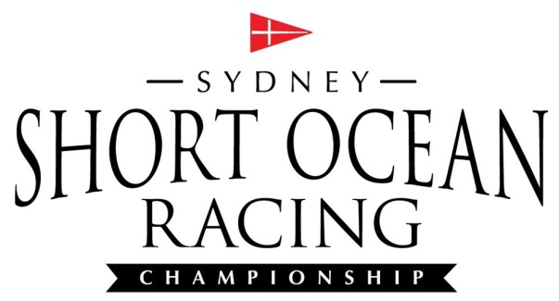
REGATTA LUNCH ORDERS

Cut-off time for orders is 12 noon Thursday 26 November
Collection time requested (Earliest 8am): _____________
Boat name: __________________________________
Contact number: ________________________________
Email to: sailing@mhyc.com.au
Description | Price* | Saturday Qty. | Sunday Qty. | Total $
10-person sandwich platter box. Various flavours. | $86.00
10-person gourmet platter box. Various Sandwiches, baguettes, and wraps. | $99.00
Ham, Cheese, & Tomato Sandwich | $9.20
Beef and Pickles Sandwich | $9.20
Grilled veggies and pesto sandwich | $9.20
Chicken Caesar Sandwich | $9.20
Schnitzel & coleslaw sandwich | $9.20
600ml water x 24 bottles | $24.00
TOTAL
*No further discounts available

Signature: _________________________ Total $___________

Credit Card details for pre-payment: Visa Mastercard AMEX
Card no: __ __ __ __ __ __ __ __ __ __ __ __ __ __ __ __
Name on card: __________________________________________
Expiry Date: __ / __
Total to be charged: $_______

