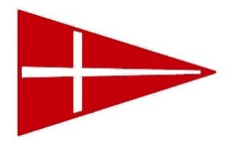
REGATTA LUNCH ORDERS – please return to MHYC office or
email info@mhyc.com.au
if possible, at least 48 hours before event commencement
Boat name: __________________________________
Ordered by: ___________________________________
Phone (mob): __________________________
Need to be collected by (approx time): ___________
Description | Price/item | Qty for Saturday | Qty for  Sunday | Total $
Ham & salad Roll | $8.50
Curried Egg & Lettuce Roll | $8.50
Falafel & salad wrap | $10.00
Rare Roast Beef & Salad Roll | $9.50
Tuna, Mayo & Dill Roll | $9.00
Crumbed Chicken Schnitzel & salad Roll | $9.50
Turkey, Cranberry Sauce & Salad roll | $9.00
Spicy Salami & Salad roll | $9.50
Kettle Chips (varied flavours) 90g size | $5.00
Bag of Ice | $5.00
Mt Franklin 600ml water | $15/6 btls  $25/12 btls
Assorted soft drink cans | $12/6 cans  $20/12 cans
TAKEAWAY BEER & WINE AVAILABLE FROM CAFE
*Please note any special requests for GF or other food allergies.
CC details for pre-payment: Visa Mastercard AMEX
Card no: __ __ __ __ __ __ __ __ __ __ __ __ __ __ __ __
Exp Date: __ / __
Name on card: __________________________________________
Total to be charged: $____________

